ERCROS ANNUAL RESULTS NOTE
FISCAL YEAR 2025

(27-02-2026)

Ercros earns EUR 8 million in ebitda and records losses of EUR 54 million

• In the 2025 financial year, Ercros has achieved a contribution of EUR 198 million, an adjusted ebitda of EUR 8 million, and records losses of EUR 54 million.

- Ercros, like other chemical companies in Europe, continues to be negatively affected by persistently weak demand, high energy costs, and strong competition from non-EU countries. In addition, the tariff war initiated by the United States has increased the presence of Asian products in Europe, further hindering the recovery of European economic activity.

- As long as the current oversupply situation persists, volumes, prices, and margins will continue to be under strong pressure.

- The objectives set out in Ercros’ cost reduction and revenue increase plan (CRP) are being met as scheduled.

- Although the benefits of the Action plan for the European chemical industry designed by the European Commission (EC) are not yet being perceived.

- Despite the losses, Ercros has reduced its net financial debt by EUR 8.6 million in 2025 and has a solid financial position, with EUR 99 million in liquidity.

- On February 10, the Spanish Securities Market Commission (CNMV, in its Spanish abbreviation) approved Bondalti Ibérica S.L.U.’s takeover bid prospectus, with the acceptance period set from February 12 to March 13, 2026 (30 calendar days).

- On 19 February, the board of directors of Ercros, S.A. issued its mandatory report, in which it rejected the takeover bid by majority vote.

- Consensus among specialized publications forecasts that the recovery of demand in the European chemical industry will begin during the second half of 2026, although this remains subject to a reasonable resolution of the current tariff crisis and the implementation of the support plan for the European chemical industry.

- In any case, Ercros will continue implementing the 3D Plan in order to advance the digitalisation of its operations, the decarbonisation of its activities, and the diversification and expansion of its portfolio. At the same time, it will maintain its presence in its operating markets, seize opportunities to defend its margins, and continue carrying out actions aimed at reducing costs and improving competitiveness.
- KEY EVENTS OF 2025

- In 2025 Ercros sold 910 thousand tons of products, a slightly lower amount than the 938 thousand tons sold in 2024: a decrease of 2.9%.

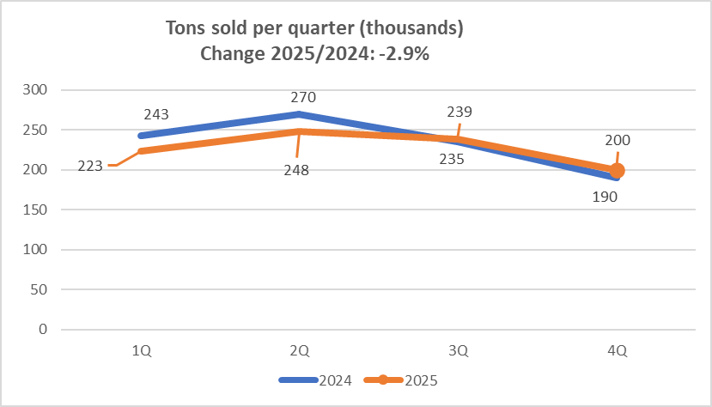

- Product sales totalled EUR 603.36 million compared to EUR 643.43 million in 2024, a decrease of EUR 40.07 million, equivalent to a drop of 6.2%

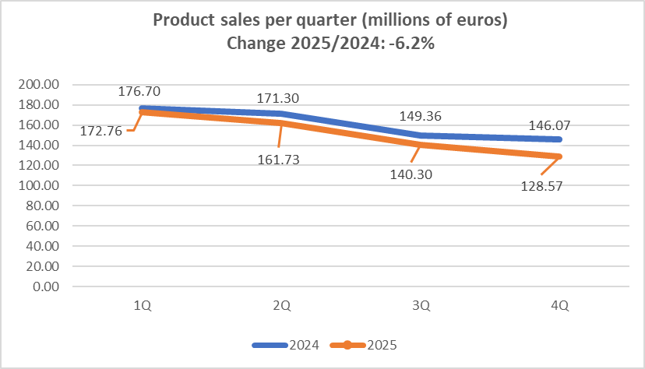

- Of the EUR 40.07 million by which sales decreased, the drop in the average price per ton accounts for EUR 21.94 million (a 54.8%), while the lower volume of tons sold accounts for EUR 18.77 million (a 46.8%). The mix effect moves in the opposite direction and explains the remaining -1.6%.

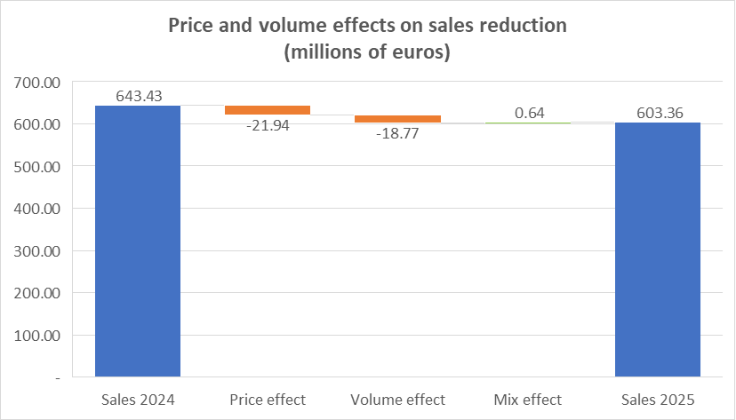

- The contribution generated by product sales and service provision in 2025 amounted to EUR 198.13 million, compared with EUR 224.62 million in 2024; a decrease of 11.8%. This reduction is the result of a EUR 40.60 million drop in sales and service provision, which exceeded the EUR 14.11 million decrease in variable costs.

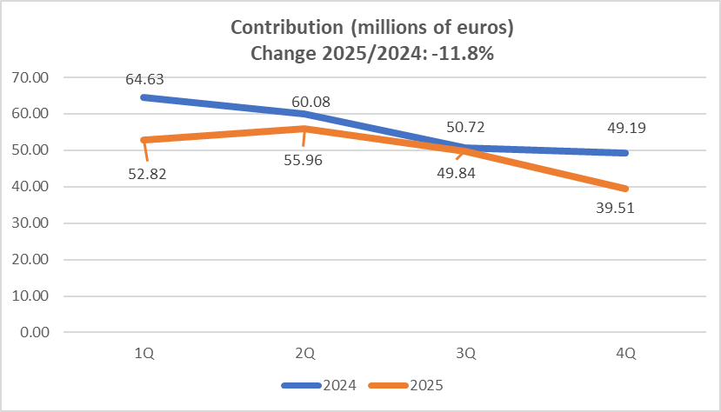
Contribution: (product sales + service provision) – procurement – utilities + change in inventories.

- Regarding contribution, in 2025 the negative price effect of EUR 21.75 million was, in absolute terms, greater than the positive unit variable cost (UVC) effect of EUR 1.22 million. The net effect of price and UVC amounts to EUR -20.53 million and explains 77.5% of the EUR -26.49 million change in contribution. The remaining 22.5% is explained by the volume effect, EUR -6.55 million (24.7%), and the mix effect, EUR 0.60 million (-2.2%).

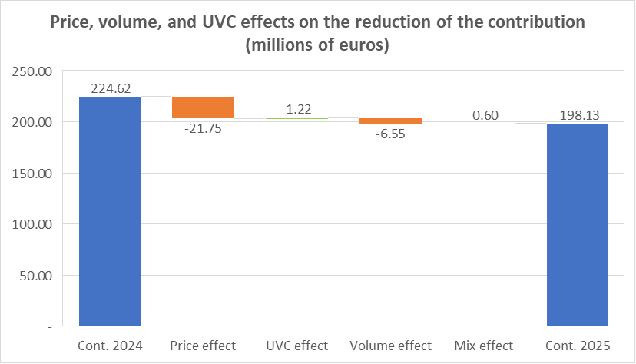

- The contribution margin (contribution divided by the sum of product sales and service provision) decreased from 33.7% in 2024 to 31.6% in 2025. This represents a change of -2.1 percentage points, driven by the increase in the relative weight of variable costs, which accounted for 66.6% of sales (plus service provision) in 2024 and 68.4% in 2025.

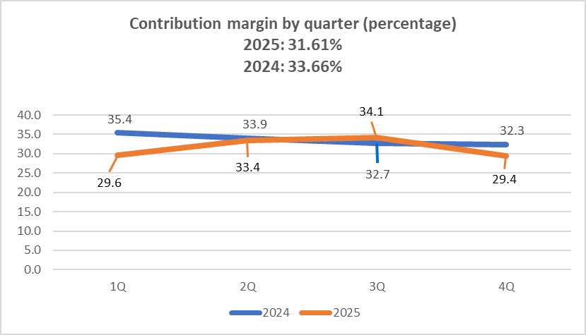
Contribution margin: contribution / (product sales + service provision).

- Adjusted ebitda for 2025 amounted to EUR 7.80 million, compared with EUR 28.63 million in 2024, representing a reduction of EUR 20.83 million (-72.8%). This decrease is smaller than the EUR 26.49 million drop in contribution due, among other factors, to higher income from indirect CO₂ emission compensations granted (which increased by EUR 6.39 million in 2025 compared with 2024).

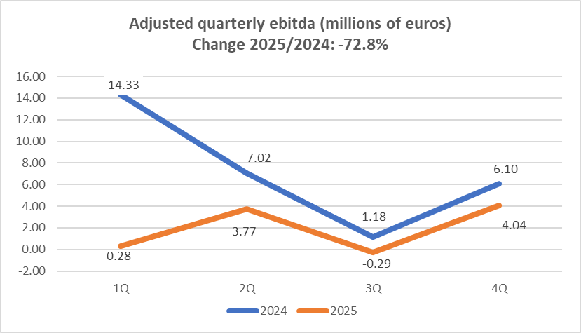
Adjusted ebitda: ebitda excluding non‑recurring items. See the “Ebitda reconciliation” table in Section B of this results note.

- Regarding 2024, the reduction in adjusted ebitda in 2025, amounting to EUR -20.83 million, is explained by: (i) the unit contribution effect of EUR -20.54 million, due to the average selling price falling more than the UVC, accounting for 98.6% of the decrease in ebitda; (ii) the volume effect of EUR -6.55 million, accounting for 31.5%; (iii) the mix effect of EUR 0.60 million, accounting for -2.9%; (iv) the increase in personnel costs of EUR -3.78 million, accounting for 18.1%; (v) the increase in income from indirect CO₂ compensation of EUR 6.39 million, accounting for -30.7%; and (vi) other income and expenses totalling EUR 3.05 million, accounting for -14.6%.

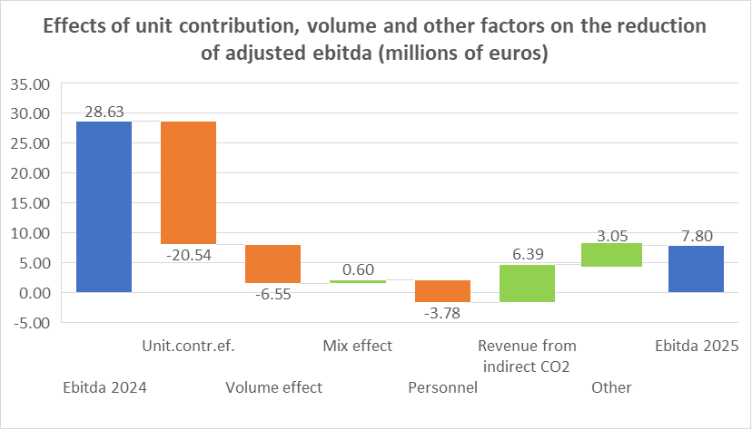
Other: change in service provision, other income, fixed costs, and non‑recurring items.
- The free cash flow (FCF) generated in 2025 amounted to EUR 20.04 million, resulting from adding to ebitda of EUR 7.80 million: (i) the refund of undue payments arising from the unconstitutionality of certain provisions of Royal Decree 3/2016, amounting to EUR 19.80 million; (ii) the collection of subsidies, amounting to EUR 17.79 million; and (iii) the reduction in working capital, of EUR 18.54 million; and subtracting: (i) investments of EUR 29.15 million; (ii) provision payments of EUR 2.93 million; and (iii) net payments for financial costs and income, amounting to EUR 11.81 million.

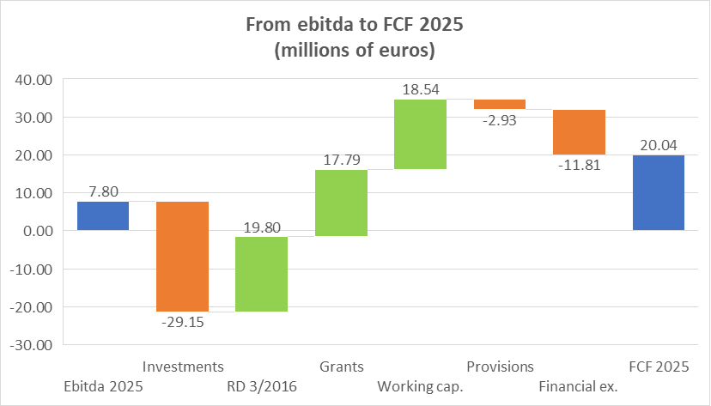

- Ercros began 2025 with EUR 133.58 million of net financial debt (NFD). Throughout 2025, debt decreased by EUR 20.04 million due to the positive FCF generated during the period; and increased (i) by EUR 7.01 million from the renewal of leases subject to IFRS 16; (ii) by EUR 0.33 million from shareholder remuneration; and (iii) by EUR 4.12 million due to other minor factors. In total, Ercros reduced its net financial debt by EUR 8.58 million, bringing it to EUR 125.00 million as of December 31, 2025.

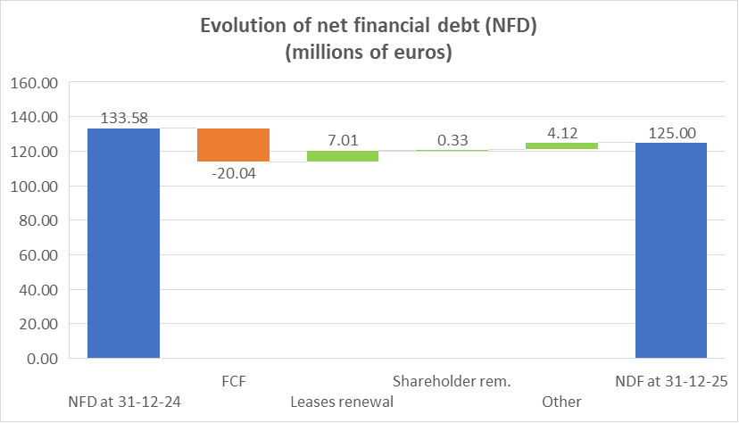

- As of December 31, 2025, Ercros had liquidity amounting to EUR 99.25 million, of which EUR 96.03 million corresponded to cash and EUR 3.22 million to undrawn credit lines. Additionally, as accounts receivable may increase, Ercros will be able to draw on the syndicated factoring financing for up to an additional 36 million euros.

- INTERIM FINANCIAL STATEMENTS

Income statement

Regarding the 2025 result, and in addition to what is indicated in Section A of this note, the following should be highlighted:

The service provision line decreased by 2.2%. Other income increased by 33.4%, mainly due to the rise in compensation for indirect CO₂ emissions, which was granted in the amount of EUR 6.39 million.

The reversal of provisions and other non-recurring income mainly includes insurance compensation income of EUR 0.35 million and the reversal of provisions of EUR 0.40 million (the 2024 amount mainly included income from the settlement of a dispute with a supplier).

The combined amount of procurements and the change in inventories of finished goods decreased by 6.0%. Supplies, meanwhile, increased by 4.7%, mainly due to higher electricity costs (12.5%) while gas decreased (‑5.7%)

Personnel expenses increased by 3.7%, mainly due to the wage increase agreed in the collective bargaining agreement (3%) and the rise in social security contributions and other social charges.

The allocation to provisions and other extraordinary expenses decreased by 43.6% due to fewer claims and environmental remediations.

Depreciation increased by 9.3% as a result of the investments made.

Negative financial results increased by 33.0%, mainly due to higher negative exchange differences, which in absolute terms has represented an increase of EUR 4.01 million. Excluding exchange differences, financial results have decreased by 9.7%.

Income tax expense includes EUR 12.13 million of deferred tax expense arising from the reduction of the deferred tax asset.

INCOME STATEMENT

Thousands of euros |  | 2025 | 2024 | %
Income |  | 662,791 | 700,358 | -5.4
Sales of finished goods |  | 603,364 | 643,426 | -6.2
Service provision |  | 23,451 | 23,989 | -2.2
Other income |  | 34,918 | 26,177 | 33.4
Reversal of prov. and other non-recurring income |  | 1,058 | 5,378 | -80.3
Incr. in invent. of finished and work-in-progress prod. |  | - | 1,388 | -
Expense |  | -656,542 | -670,982 | -2.2
Procurement |  | -299,909 | -326,838 | -8.2
Dec. in invent. of finished and work-in-progress prod. |  | -5,917 | - | -
Supplies |  | -122,857 | -117,341 | 4.7
Transport |  | -42,810 | -43,274 | -1.1
Personnel expenses |  | -104,748 | -100,966 | 3.7
Other operating expenses |  | -77,689 | -77,935 | -0.3
Provisions and other extraordinary expenses |  | -2,612 | -4,628 | -43.6
Ebitda |  | 6,249 | 29.376 | -78.7
Amortizations |  | -34,390 | -31,460 | 9.3
Impairment/reversal of impairment of asset value |  | - | -1,055 | -
Ebit |  | -28,141 | -3.139 | ×9.0*
Financial result |  | -12,127 | -9,115 | 33.0
Pre-tax profit/loss |  | -40,268 | -12,254 | ×3.3*
Income tax |  | -13,317 | 597 | -
Profit/loss for the period |  | -53,585 | -11,657 | ×4.6*
* Times that the 2025 figure exceeds that of 2024 (in absolute terms).

RECONCILIATION OF ADJUSTED EBITDA

Thousands of euros | 2025 | 2024 | %
Ebitda | 6,249 | 29,376 | -78.7
Atypical income items | -1,058 | -5,378 | -80.3
Atypical items of expenditure | 2,612 | 4,628 | -43.6
Adjusted ebitda | 7,803 | 28,626 | -72.7

Balance sheet

Regarding the 2025 year‑end balance sheet compared with 2024, the following points should be highlighted:

Non‑current assets decreased by EUR 2.6 million, mainly due to the following: on the negative side, the reduction of the deferred tax asset by EUR 13.40 million; and on the positive side, the increase in property, plant and equipment, intangible assets and investment property by EUR 10.19 million, as additions to fixed assets during the year exceeded depreciation charges.

Working capital decreased by EUR 61.81 million as a result of a EUR 59.21 million decrease in current assets and EUR 2.60 million increase in current liabilities. Current assets fell mainly due to: (i) the reduction in inventories (EUR 13.22 million); (ii) the collection of the receivable from the tax authorities relating to undue payments arising from the unconstitutionality of certain provisions of Royal Decree 3/2016 (EUR 19.80 million); and (iii) the decrease in trade receivables (EUR 19.63 million). Current liabilities increased mainly due to the rise in accounts payable related to fixed‑asset suppliers

Equity decreased by EUR 53.91 million, the net result of deducting the loss for the period (EUR 53.58 million) and the attendance premium for the shareholders’ meeting (EUR 0.33 million).

Provisions and other liabilities decreased by EUR 1.92 million, mainly due to payments associated with the dismantling of facilities and various environmental remediations.

ECONOMIC ANALYSIS OF THE BALANCE SHEET

Thousands of euros |  | 31-12-25 | 31-12-24 | Change | %
Non-current assets |  | 401,198 | 403,800 | -2,602 | -0.6
Working capital |  | 36,181 | 97,988 | -61,807 | -63.1
 | Current assets | 148,782 | 207,994 | -59,212 | -28.5
 | Current liabilities | -112,601 | -110,006 | -2,595 | 2.4
Resources used |  | 437,379 | 501,788 | -64,409 | -12.8
Equity |  | 287,247 | 341,157 | -53,910 | -15.8
Net financial debt |  | 125,001 | 133,578 | -8,577 | -6.4
Provisions and other debts |  | 25,131 | 27,053 | -1,922 | -7.1
Source of funds |  | 437,379 | 501,788 | -64,409 | -12.8

DETAIL OF NET FINANCIAL DEBT

Thousands of euros | 31-12-25 | 31-12-24 | Change | %
Loans | 88,446 | 91,013 | -2,567 | -2.8
Lease creditors | 12,101 | 13,982 | -1,881 | -13.5
Revolving financing | 122,510 | 67,340 | 55,170 | 81.9
Gross financial debt | 223,057 | 172,335 | 50,722 | 29.4
Treasury | -96,029 | -36,729 | -59,300 | 161.5
Deposits | -2,027 | -2,028 | 1 | -
Net financial debt | 125,001 | 133,578 | -8,577 | -6.4

Voluntary public takeover bid

On 10 February, the Spanish National Securities Market Commission (CNMV) approved the prospectus for the takeover bid launched by Bondalti Ibérica, S.L.U. (Bondalti), at a price of EUR 3.505 per share. This price does not qualify as a fair price.

Bondalti has made the bid subject to a non-waivable condition requiring a minimum level of acceptance representing more than half of the voting rights, which means at least 45,718,100 shares.

The acceptance period for the bid runs from 12 February to 13 March 2026, a total of 30 calendar days.

On 19 February, the board of directors of Ercros, S.A. issued its mandatory report on the bid, rejecting Bondalti’s offer by majority vote.

If Bondalti’s bid were to succeed, it would result in a change of control at Ercros. In this situation, certain financing lines, with an outstanding balance of EUR 172 million as of 31 December 2025, provide for early maturity in the event of a change of control. Ercros has requested from the relevant institutions a waiver of the mandatory repayment triggered by a change of control, in the event that Bondalti acquires control of Ercros, which has not been approved by the financial institutions.

Bondalti’s prospectus does not include a specific solution to this situation, which would arise if its bid is successful, although Bondalti states its intention to resolve this through transitional financing.

Bondalti also plans to integrate Ercros into its chemical business and to review the strategic plan, which could be significantly altered. Ercros would become one of the group’s chemical subsidiaries, whose activities would be constrained by the financing agreements entered into by Bondalti to fund the acquisition of Ercros, S.A.

Bondalti also foresees the delisting of Ercros’ shares.

- RESULTS BY BUSINESS

The weakness in demand in the European chemical sector, which began in mid-2022, continued throughout 2025.

In this context, the efforts of Ercros’ business units remained focused on adjusting production levels to demand while defending margins as far as possible in a market environment characterised by excess supply and strong competition. Cost-reduction and competitiveness-improvement measures continue to be implemented without affecting industrial activity.

In 2025, compared with 2024, sales in the chlorine derivatives division fell by 4.9%, due to a 4.5% decrease in the average selling price, combined with a 0.3% decline in volumes sold. In addition, there was a sharp increase in energy costs. As a result, the division’s ebitda dropped to EUR 7.21 million, bringing the ebitda-to-sales ratio to 2.0%.

In the intermediate chemicals division, sales fell by 9.6% in 2025 compared with 2024, due to a 9.7% decrease in volumes sold, while the average price of the division’s products remained similar. This, together with higher energy and procurement costs, led to a EUR 14.57 million reduction in the division’s ebitda to EUR 0.4 million, bringing the ebitda-to-sales ratio to 0.2%, compared with 7.7% in 2024.

The pharmaceuticals division experienced a 3.6% decrease in sales, driven by a 7.7% fall in volumes sold, despite a 4.5% increase in selling prices. Operating costs, meanwhile, increased, resulting in a reduction of ebitda to EUR 0.2 million.

RESULTS BY BUSINESS

Thousands of euros | 2025 | 2024 | %
Chlorine derivatives division
Product sales | 367,141 | 386,224 | -4,9
Adjusted ebitda | 7,209 | 12,452 | -42,1
Adjusted ebitda/product sales (%) | 2.0 | 3.2 | -39.1
Intermediate chemicals division
Product sales | 175,839 | 194,558 | -9.6
Adjusted ebitda | 399 | 14,972 | -97.3
Adjusted ebitda/product sales (%) | 0.2 | 7.7 | -97,1
Pharmaceuticals division
Product sales | 60,384 | 62,644 | -3.6
Adjusted ebitda | 195 | 1,202 | -83.8
Adjusted ebitda/product sales (%) | 0.3 | 1.9 | -83.2

- EXPANDED DIVERSIFICATION, DIGITALISATION AND DECARBONISATION PLAN: THE 3D PLAN

In the diversification dimension, during the 2021–2025 period, the following projects entered into operation: the expansion of polyols production capacity at the Tortosa plant; the expansion of moulding compounds production at the Cerdanyola plant; the expansion of fosfomycin trometamol, gentamycin and sterile micronized fusidic acid production in Aranjuez; the expansion of TCCA capacity at the Sabiñánigo plant; and the industrial scale-up of the fermentation and extraction processes for the new antibiotic vancomycin at the extraction plant in Aranjuez, currently under validation.

Regarding the digitalisation dimension, the following projects, among others, have been completed: business intelligence systems for the procurement, logistics, production and maintenance areas; tracking and monitoring systems for containers shipped by sea and for land-based shipments; and mobility solutions in industrial environments (work permits and meter readings). Big Data and IoT, mobility and logistics, infrastructure improvement, cybersecurity, workplace optimisation and automation projects continue to progress, as well as the sensorisation and upgrading of control systems in the production area.

In the decarbonisation dimension, during the 2021–2025 period the following projects were completed: (i) improvements in energy efficiency in Tortosa and optimisation of energy consumption in Cerdanyola; (ii) replacement of lighting with LED technology at Ercros plants; (iii) optimisation of chemical product and raw material consumption in Aranjuez; (iv) improved utilisation of hydrogen in Sabiñánigo, Vila-seca I and Vila-seca II; (v) salt recrystallisation in Sabiñánigo; (vi) recycling of moulding compounds in Cerdanyola; and (vii) photovoltaic parks in Flix and Monzón. In addition, decarbonisation projects included in the PERTE programme have been launched: steam production using an electric boiler in Vila-seca I; steam generation using biomass at the Vila-seca II plant; heat recovery and reuse at the VCM and PVC plants in Vila-seca II; and improved utilisation of hydrogen (phase two) produced in Vila-seca I.

- FULFILMENT OF THE FORECAST

The table below details the actual figures obtained in 2025 for finished goods sales, contribution, adjusted ebitda and net profit (loss), alongside the company’s 2025 forecast as published in the third-quarter results release.

As can be seen, Ercros met its forecast regarding finished goods sales, but did not meet the forecast for contribution, adjusted ebitda or net profit, which came in slightly below the lower end of the forecast range.

Finished goods sales amounted to EUR 603.36 million, within the forecast range of [595 – 610]. Contribution, at EUR 198.13 million, was slightly below the lower end of the forecast range [200 – 205]. Adjusted ebitda, at EUR 7.8 million, fell short of the forecast range [10 – 15]. Finally, the net loss for the year, EUR 53.6 million, exceeded the forecast range [45 – 50].

2025 FORECAST AND ACTUAL RESULTS

Millions of euros | Forecast | Actual data
Sale of finished products | 595 – 610 | 603
Contribution | 200 – 205 | 198
Adjusted ebitda | 10 – 15 | 8
Losses * | 45 – 50 | 54
* The estimate was prepared under the assumption of no asset impairment.

- FORECAST FOR 2026

Specialised industry publications forecast that demand in the European chemical sector will begin to recover during the second half of 2026, although this remains contingent on a reasonable resolution of the current tariff crisis and the implementation of the European Chemical Industry Support Plan.

Ercros, like other companies in the European chemical sector, continues to be affected by persistently weak demand, high energy costs and intense competition from non-EU countries. As long as the current situation of excess supply persists, volumes, prices and margins will remain under significant pressure.

In addition, the tariff war initiated by the United States has increased the flow of Asian chemical products into Europe, weakening the recovery of economic activity in the region.

In any case, Ercros will continue to implement the 3D Plan in order to advance the digitalisation of its operations, the decarbonisation of its activities, and the diversification and expansion of its product portfolio. At the same time, it will maintain its presence in the markets in which it operates, take advantage of opportunities to defend its margins, and continue to carry out actions aimed at reducing costs and improving competitiveness.

Barcelona, 27 February 2026

